SEG Awards Entry Level Award/Certificate/Diploma

in Motor Vehicle Studies (Entry 3)

Learner Assessment Record Book
Motor Vehicle Units

Learners Name
SEG Awards Registration Number
Centre Name
Assessor 1 Name
Assessor 2 Name

DECLARATION OF AUTHENTICITY

This declaration must be completed and signed by the learner and countersigned
by the tutor / assessor and covers all evidence submitted for moderation.

Learner Name
Unique Learner Number (ULN) |  | SEG  Learner Reg. ID
Qualification Title
Centre Name

Learner statement of authenticity

Before signing please read the guidance below.

I confirm, that the attached assignment / portfolio is all my own work and does not include any work completed by anyone other than myself. I have completed the assignment / portfolio in accordance with SEG Awards’ instructions and within the time limits set by my centre.

Signature |  | Date

Centre confirmation of authenticity

On behalf of …………………………………….(insert centre name), I confirm that the above mentioned learner, to the best of my knowledge, is the sole author of the completed assignment / portfolio attached, and the assessments have been completed under the required conditions.

Signed |  | Date
Name
Title

Guidance for Learners

You have been asked to sign this Declaration of Authenticity and place it at the front of your portfolio or course work assessment. It confirms that the work you have submitted for assessment is your own and that you have not copied it from someone else or allowed another learner to copy it from you.

When preparing any course work it is good practice to undertake research using information from published sources. If you quote directly from these sources then this must be indicated in your work by using quotation marks and referencing the document from which the quotation was taken. You must then comment in your own words on any ideas expressed.

Assessors, internal verifiers and SEG Awards’ external moderators and verifiers are subject specialists who can spot the use of published materials that may be passed as your own words or ideas.

If you do copy words from a published source and do not indicate their reference you will be committing plagiarism. This is considered a form of cheating and may result in your assessment being declared void.

SEG Awards Entry Level Award/Certificate/Diploma in Motor Vehicle Studies (Entry 3)

INDIVIDUAL LEARNING PLAN
LEARNERS NAME |  |  |  |  |  | ASSESSOR/S NAME/S
COURSE START DATE |  | COURSE WEEKLY HOURS |  |  |  |  |  |  | TOTAL COURSE HOURS
UNIT TITLE |  |  |  | CREDIT  VALUE | AWARD |  | CERT | DIP |  | DATE  STARTED | DATE  COMPLETED
Health and safety awareness [J/506/0641] |  |  |  | 1
Motor vehicle workshop tools and equipment [J/502/4657] |  |  |  | 2
Principles of engine components and operations [L/502/4658] |  |  |  | 2
Check and maintain vehicle fluid levels [M/504/1386] |  |  |  | 1
Check and maintain motor vehicle external lights [T/504/1387] |  |  |  | 1
Checking and maintaining car tyre pressure and tread [M/506/0861] |  |  |  | 1
Remove and replace motor vehicle road wheels [A/504/1388] |  |  |  | 1
Motorcycle construction [J/502/4674] |  |  |  | 2
Routine motorcycle checks [L/502/4675] |  |  |  | 2
Routine braking system checks [M/502/4667] |  |  |  | 2
Routine vehicle checks [M/502/4670] |  |  |  | 2
Clean a vehicle exterior and interior [F/504/1389] |  |  |  | 1
Remove and replace spark plugs [T/504/1390] |  |  |  | 1
Introduction to vehicle exhaust systems [M/501/7024] |  |  |  | 2
Introduction to vehicle ignition systems [A/501/7026] |  |  |  | 2
Introduction to customer care [D/501/7021] (Level 1) |  |  |  | 1
Total credits

INDIVIDUAL LEARNING PLAN (PSD UNITS – DIPLOMA ONLY)
UNIT TITLE | Level |  | CREDIT  VALUE | AWARD | CERT | DIP | DATE  STARTED | DATE  COMPLETED
Communicating with others at work [H/500/5887] | E3 |  | 1
Communicating with others at work [F/500/5010] | L1 |  | 1
Applying for a job [M/500/5892] | E3 |  | 1
Applying for a job [H/500/5789] | 1 |  | 1
Maintaining work standards [M/500/5889] | E3 |  | 2
Maintaining work standards [L/500/5009] | 1 |  | 2
Career exploration [A/601/4637] | E3 |  | 1
Career exploration[L/601/4688] | 1 |  | 2
Overcoming barriers to work [J/601/4639] | E3 |  | 1
Overcoming barriers to work [F/601/4705] | 1 |  | 1
Introduction to customer care [D/501/4409] | E3 |  | 1
Introduction to customer Care [D/501/7021] | 1 |  | 1
Managing personal finance [F/501/6931] | E3 |  | 3
Working towards goals [D/502/0453] | E3 |  | 2
Working towards goals [J/502/0463] | 1 |  | 2
Developing self [M/502/0456] | E3 |  | 2
Developing self [K//502/0469] | 1 |  | 2
Environmental awareness [R/502/0658] | E3 |  | 2
Environmental awareness [Y/502/0659] | 1 |  | 2
Individual rights and responsibilities [A/502/0458] | E3 |  | 1
Individual rights and responsibilities [K/502/0472] | 1 |  | 1
Preparation for work [A/502/0461] | E3 |  | 2

Preparation for work [J/502/0477] | 1 |  | 2
Working as part of a group [K/502/0455] | E3 |  | 2
Working as part of a group [R/502/0465] | 1 |  | 2
Dealing with problems in daily life [H/502/0454] | E3 |  | 2
Dealing with problems in daily life [L/502/0464] | 1 |  | 2
Total credits

SEG Awards Entry Level Award/Certificate/Diploma in Motor Vehicle Studies (Entry 3)

SUMMARY OF ACHIEVEMENT RECORD
QUALIFICATION CLAIMED | FULL AWARD  (TICK) | FULL CERTIFICATE  (TICK) | FULL DIPLOMA  (TICK) | UNITS OF CREDIT  (TICK)

Unit Title |  | Learner |  | Tutor |  | Internal moderator |  | External Moderator
 |  | Signature | Date | Signature | Date | Signature | Date | Signature | Date
Health and safety awareness [J/506/0641]
Motor vehicle workshop tools and equipment [J/502/4657]
Principles of engine components and operations [L/502/4658]
Check and maintain vehicle fluid levels [M/504/1386]
Check and maintain motor vehicle external lights [T/504/1387]
Checking and maintaining car tyre pressure and tread [M/506/0861]
Remove and replace motor vehicle road wheels [A/504/1388]
Motorcycle construction [J/502/4674]
Routine motorcycle checks [L/502/4675]
Routine braking system checks [M/502/4667]
Routine vehicle checks [M/502/4670]
Clean a vehicle exterior and interior [F/504/1389]
Remove and replace spark plugs [T/504/1390]
Introduction to vehicle exhaust systems [M/501/7024]
Introduction to vehicle ignition systems [A/501/7026]
Introduction to customer care [D/501/7021] (Level 1)

SEG Awards Entry Level Award/Certificate/Diploma in Motor Vehicle Studies (Entry 3)

SUMMARY OF ACHIEVEMENT RECORD (PSD UNITS – DIPLOMA ONLY)

Unit Title | Level | Learner |  | Tutor |  | Internal moderator |  | External Moderator
 |  | Signature | Date | Signature | Date | Signature | Date | Signature | Date
Communicating with others at work [H/500/5887]
Communicating with others at work [F/500/5010]
Applying for a job [M/500/5892]
Applying for a job [H/500/5789]
Maintaining work standards [M/500/5889]
Maintaining work standards [L/500/5009]
Career exploration [A/601/4637]
Career exploration[L/601/4688]
Overcoming barriers to work [J/601/4639]
Overcoming barriers to work [F/601/4705]
Introduction to customer care [D/501/4409]
Introduction to customer Care [D/501/7021]
Managing personal finance [F/501/6931]
Working towards goals [D/502/0453]
Working towards goals [J/502/0463]
Developing self [M/502/0456]
Developing self [K//502/0469]
Environmental awareness [R/502/0658]
Environmental awareness [Y/502/0659]
Individual rights and responsibilities [A/502/0458]
Individual rights and responsibilities [K/502/0472]
Preparation for work [A/502/0461]
Preparation for work [J/502/0477]
Working as part of a group [K/502/0455]
Working as part of a group [R/502/0465]
Dealing with problems in daily life [H/502/0454]
Dealing with problems in daily life [L/502/0464]

UNIT J/506/0641 HEALTH AND SAFETY AWARENESS

ASSESSMENT CRITERIA RECORD

Specification Reference | Assessment  Criteria | Task No
1.1 | State who they should tell in the event of an accident | 1
1.2 | Give an example of an emergency and state one thing they should do if one happens | 1
1.3 | Identify simple safety sign | 2
2.1 | Wear safety clothing and equipment as advised | 3
2.2 | Follow specific instructions concerning health and safety practice in relation to a given task | 3

ASSESSOR FEEDBACK ON UNIT COMPLETION
This confirms unit completion and should offer supportive guidance to the learner

Unit J/506/0641 | Assessment Criteria 1.1,1.2 | Task No 1

Task: Accidents and Emergencies

Learner Instructions

If correct safety procedures are followed, accidents and emergencies should not happen but it is important that you know what to do if they do.

If an accident happens you should immediately tell;
An emergency is a situation that poses an immediate risk to health, life, property or the environment. In the table below, give two examples of emergencies that could occur in your workshop and one thing you should do if one happens

 | Example | One thing to do
Emergency 1
Emergency 2

Assessor Declaration
In signing this sheet the assessor and learner confirm that all the operations in this task were carried out by the named learner and the learner observed safe working practices at all times.

Assessor Signature…………………………………………………….........Date…………………………..

Learner Signature.………………………………………………………..…….Date…………………………..

Unit 0J/506/0641 | Assessment Criteria 1.3 | Task No 2

Task: Safety Signs

Learner Instructions
From the list below match the sign above with the correct instruction

1. Emergency Exit |  | 2.Boots must be worn | 3. No Naked Flames
4. First Aid |  | 5. No Smoking | 6. Protective clothing must be worn
 |  |  |  | 
Instruction Number; | Instruction Number; |  |  | Instruction Number;
 |  |  |  | 
Instruction Number; | Instruction Number; |  |  | Instruction Number;

Assessor Declaration
In signing this sheet the assessor and learner confirm that all the operations in this task were carried out by the named learner and the learner observed safe working practices at all times.

Assessor Signature…………………………………………………….........Date…………………………..

Learner Signature.………………………………………………………..…….Date…………………………..

Unit J/506/0641 | Assessment Criteria 2.1, 2.2 | Task No 3

Task: Safety Clothing and Safe Practice

Learner Instructions

During your practical tasks, you will need to wear particular protective clothing and follow safe practices.

Choose 3 tasks you have completed and identify the protective clothing and safe practice required.

Task | Protective Clothing | Safe Practice Required
1:
2:
3:

Assessor Declaration
In signing this sheet the assessor and learner confirm that all the operations in this task were carried out by the named learner and the learner observed safe working practices at all times.

Assessor Signature…………………………………………………….........Date…………………………..

Learner Signature..…………………………………………………….........Date…………………………..

UNIT J/502/4657 MOTOR VEHICLE TOOLS AND EQUIPMENT

ASSESSMENT CRITERIA RECORD

Specification Reference | Assessment  Criteria | Evidence  Reference
1.1 | Identify common hand tools found in a motor vehicle workshop | 1
1.2 | Identify common equipment found in a motor vehicle workshop | 1
2.1 | Demonstrate the safe use of common hand tools found in a motor vehicle workshop | 1
2.2 | Demonstrate the safe use of common equipment found in a motor vehicle workshop | 1
3.1 | Name the types of measuring equipment commonly used in a motor vehicle workshop | 2
4.1 | Identify the types of locking device commonly found on a motor vehicle | 2
4.2 | Demonstrate the correct use of tools when using locking devices commonly found on a motor vehicle | 2

ASSESSOR FEEDBACK ON UNIT COMPLETION
This confirms unit completion and should offer supportive guidance to the learner

J/502/4657 | Assessment Criteria 1.1, 1.2, 2.1, 2.2 | Task No 1

Task: Hand Tools and Garage Equipment

Learner Instructions
Below are examples of hand tools and garage equipment. Identify the name of each, where they would be used and one safety precaution to be taken when using each of them.

Hand Tools

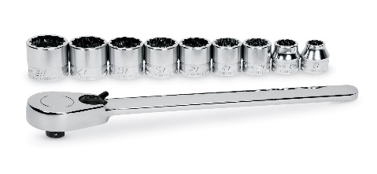 |  | 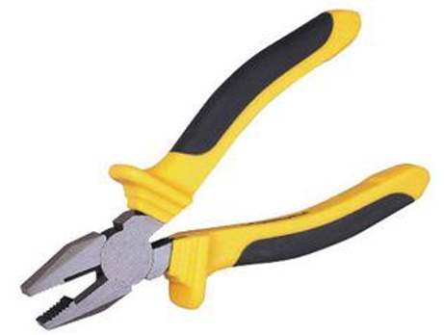 |  | 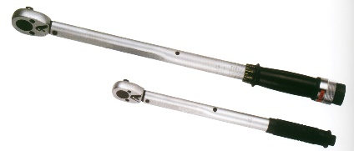
Name |  | Name |  | Name
Use |  | Use |  | Use
Safety Precaution |  | Safety Precaution |  | Safety Precaution
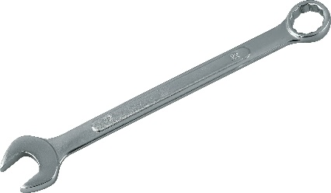 |  | 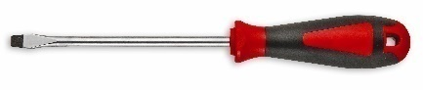 |  | 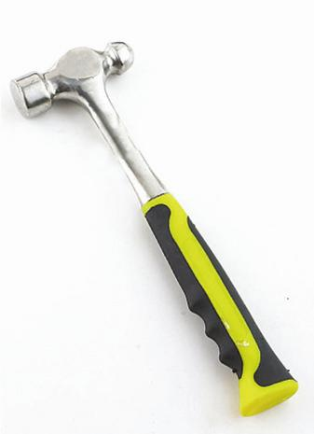
Name |  | Name |  | Name
Use |  | Use |  | Use
Safety Precaution |  | Safety Precaution |  | Safety Precaution

Garage Equipment

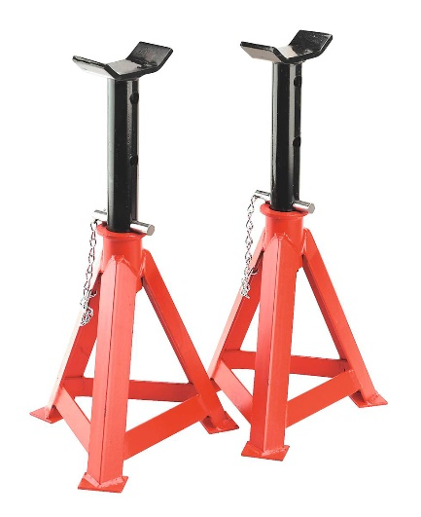 |  | 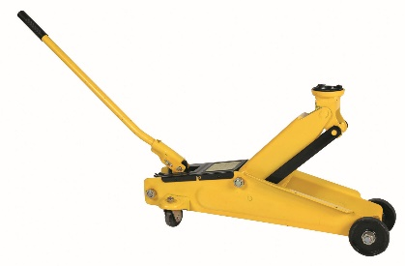 |  | 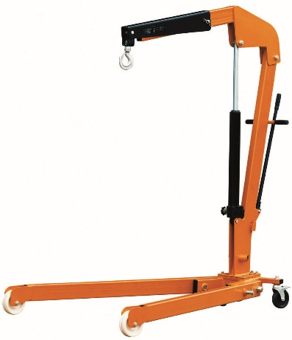
Name: |  | Name: |  | Name:
Use: |  | Use: |  | Use:
Safety Precaution |  | Safety Precaution |  | Safety Precaution
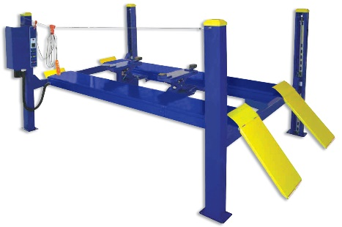 |  | 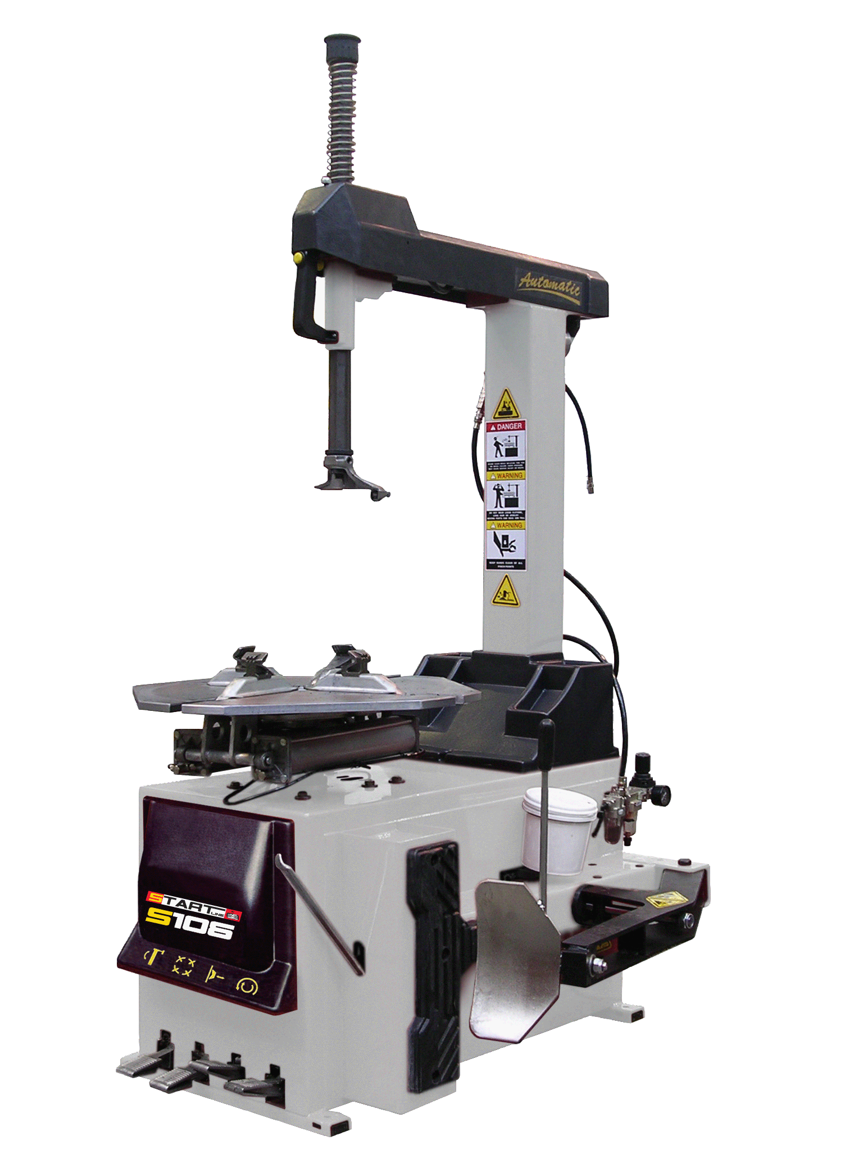 |  | 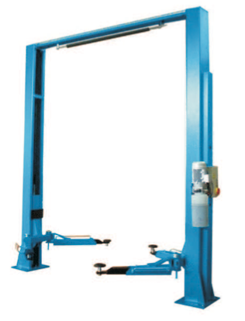
Name: |  | Name: |  | Name:
Use: |  | Use: |  | Use:
Safety Precaution |  | Safety Precaution |  | Safety Precaution

Assessor Declaration
In signing this sheet the assessor and learner confirm that all the operations in this task were
carried out by the named learner and the learner observed safe working practices at all times.

Assessor Signature…………………………………………………….........Date…………………………..

Learner Signature……………………………………………………..........Date…………………………...
Unit J/502/4657 | Assessment Criteria 3.1, 4.1, 4.2 | Task No 2

Task: Measuring Equipment and Locking Devices

Learner instructions

Below are examples of measuring equipment. Identify in the table below the name of each and one example of where they would be used
Measuring equipment
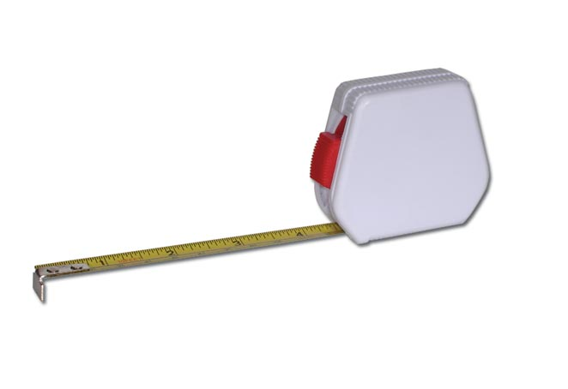 |  | 
Name: |  | Name:
Use: |  | 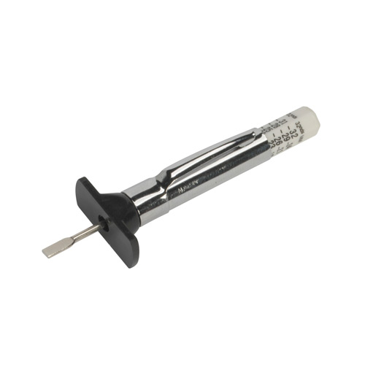  Use:
Safety Precaution |  | Safety Precaution
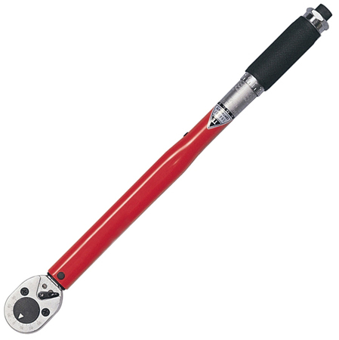
Name: |  | Name:
Use: |  | Use:
Safety Precaution |  | Safety Precaution

Learner instructions

Below are examples of locking devices. Identify in the table below the name of each and one example of where they would be used

Locking Devices
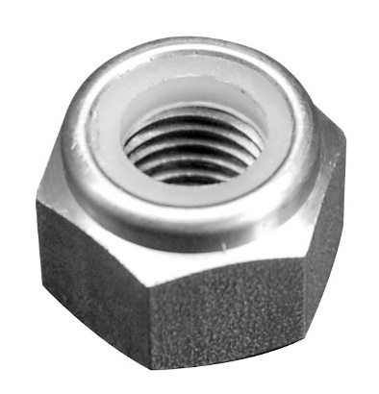 |  |  |  | 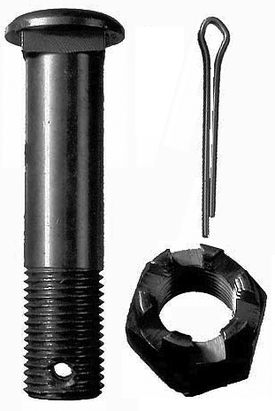
Name: |  | Name: |  | Name:
Use: |  | Use: |  | Use:
Safety Precaution |  | Safety Precaution |  | Safety Precaution

Assessor Declaration
In signing this sheet the assessor and learner confirm that all the operations in this task were carried out by the named learner and the learner observed safe working practices at all times.

Assessor Signature…………………………………………………….........Date………………………….

Learner Signature..…………………………………………………...........Date………………………….

UNIT L/502/4658 PRINCIPLES OF ENGINE COMPONENTS
AND OPERATIONS

ASSESSMENT CRITERIA RECORD

Specification Reference | Assessment  Criteria | Evidence  Reference
1.1 | Use appropriate Personal Protective Equipment and methods when working on engines | 2
2.1 | State the four stroke cycle | 1
2.2 | Identify the main engine components | 1
2.3 | State using simple terms their purpose within the engine | 1
3.1 | Demonstrate how to remove and refit a range of simple engine components from a (non-running) stand engine to include | 2
3.2 | Demonstrate the correct use of tools and equipment | 2

ASSESSOR FEEDBACK ON UNIT COMPLETION
This confirms unit completion and should offer supportive guidance to the learner

Unit L/502/4658 | Assessment Criteria 2.1, 2.2, 2.3 | Task No 1

Task: Spark Ignition Engine Component Recognition

Instructions to learners
Identify the engine components labeled in the diagram below and state their purpose within the engine
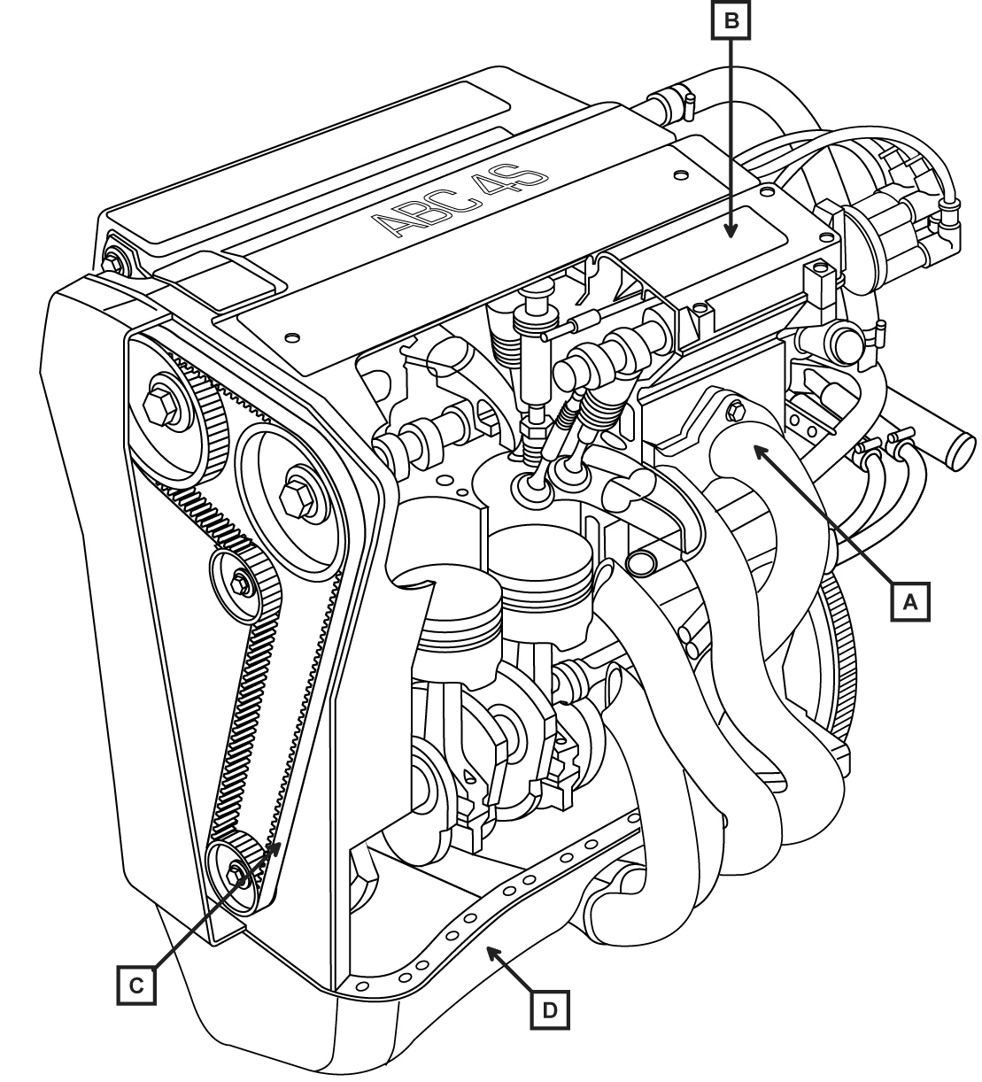
Component | Letter | Purpose within Engine
Cam Cover
Timing Belt
Manifold
Sump

Four stroke Cycle
Complete the table below showing the actions at the start of each stroke
STROKE | Compression |  |  |  |  |  | Power
Piston at |  |  | TDC |  | BDC |  | TDC
Inlet Valve | Closed |  | Opening |  | Closed
Piston Moving | Upward |  | Downward |  |  |  | Downward
Exhaust valve |  |  |  |  | Open |  | Closed
The correct order of the strokes are

Assessor Declaration
In signing this sheet the assessor and learner confirm that all the operations in this task were carried out by the named learner and the learner observed safe working practices at all times.

Assessor Signature……………………………………………………........Date……………………….

Learner Signature…………………………………………………………..….Date……………………….

Unit L/502/4658 | Assessment Criteria 1.1 & 2.2 | Task No 2

Task: Remove and Refit Engine Components

Instructions to Assessors
The following tasks can be carried out on a non-running stand engine that is securely held.
Tasks may be combined to increase the complexity

Instructions to Learners
Remove and refit THREE engine components from the list below ensuring the tools and sources of data used are recorded in the task boxes provided

3 Components from;

Inlet/Exhaust Manifold | Timing Belt Tensioner | Engine Timing Belt
Flywheel | Water Pump | Engine Mounting
Motorcycle Cylinder Head | Motorcycle Barrel | Motorcycle Oil Cooler

Task 1, Component:
PPE Used | Sources of Data Used | Tools Used

Task 2, Component:
PPE Used | Sources of Data Used | Tools Used

Task 3, Component:
PPE Used | Sources of Data Used | Tools Used

Assessor Declaration
In signing this sheet the assessor and learner confirm that all the operations in this task were carried out by the named learner and the learner observed safe working practices at all times.

Assessor Signature…………………………………………………….........Date…………………………..

Learner Signature..………………………………………………………..…..Date…………………………..

UNIT M/504/1386 CHECK AND MAINTAIN VEHICLE FLUID LEVELS

ASSESSMENT CRITERIA RECORD

Specification Reference | Assessment  Criteria | Evidence  Reference
1.1 | Demonstrate safe working practices when checking vehicle fluid levels | 1
1.2 | Use correct PPE required to carry out given tasks | 1
1.3 | Dispose of waste products in line with environmental guidance | 1
1.4 | Clean and store tools, equipment and PPE safely | 1
2.1 | Recognise fluid reservoirs and associated fluids | 1
2.2 | Check and maintain fluid levels using the correct type and grade of fluid | 1
2.3 | Ensure reservoir caps are replaced securely | 1

ASSESSOR FEEDBACK ON UNIT COMPLETION
This confirms unit completion and should offer supportive guidance to the learner

Assessor Declaration
In signing this sheet the assessor and learner confirm that all the operations in this task were carried out by the named learner and the learner observed safe working practices at all times.

Assessor Signature………………………Date………………

Learner Signature…………………………Date……………

Unit M/504/1386 | Assessment Criteria All | Task No 1
Task Check and Maintain Fluid Levels

Assessor Declaration
In signing this sheet the assessor and learner confirm that all the operations in this task were carried out by the named learner and the learner observed safe working practices at all times.

Assessor Signature…………………………………………………….........Date…………………………..

Learner Signature..………………………………………………………..…..Date…………………………..

Vehicle details |  | Tools Used |  |  |  | PPE Used
Make…………………

Model…………………

Year…………………….

Instructions to learners
Check THREE fluid levels on a vehicle and complete the table below

Fluid Level Checked | Fluid Specification |  | Level  O/K  (Y/N) | Topped Up  (Y/N) | Waste Disposal

Engine Oil

Engine Coolant

Brake Fluid

Transmission Fluid

Windscreen Washer Reservoir

UNIT T/504/1387 CHECK AND MAINTAIN MOTOR VEHICLE EXTERNAL LIGHTS

ASSESSMENT CRITERIA RECORD

Specification Reference | Assessment  Criteria | Evidence  Reference
1.1 | Demonstrate safe working practices when checking motor vehicle lights | 1
1.2 | Use correct PPE required to carry out given tasks | 1
1.3 | Clean and store tools, equipment and PPE safely | 1
2.1 | Identify external lights on a vehicle | 1
2.2 | State reasons for checking that all external lights are in working order | 1
3.1 | Check external vehicle lights for correct functioning | 1
3.2 | Maintain external vehicle lights safely | 1

ASSESSOR FEEDBACK ON UNIT COMPLETION
This confirms unit completion and should offer supportive guidance to the learner

Unit T/504/1387 | Assessment Criteria All | Task No 1

Task: External Lighting Check
PPE Used

Instructions to Learners

State TWO reasons for checking and maintaining vehicle external lights

- ……………………………………………………………..

- ……………………………………………………………..

Inspect the condition and operation of vehicle exterior lights and complete the report below.

Vehicle Details | Lights | Report
Make__________________  Model_________________  Year__________________ | Front and rear sidelights
Front headlamps
(dip & main beam)
Direction indicators
(front, side and rear)
Stop lights including high
level
 | Reverse lights
 | Rear fog light
Number plate illumination
light
 | Hazard warning lights

Assessor Declaration
In signing this sheet the assessor and learner confirm that all the operations in this task were carried out by the named learner and the learner observed safe working practices at all times.

Assessor Signature…………………………………………………….........Date…………………………..

Learner Signature.………………………………………………………..…….Date…………………………..

M/506/0861 CHECKING AND MAINTAINING CAR TYRE PRESSURES AND TREAD

ASSESSMENT CRITERIA RECORD

Specification Reference | Assessment  Criteria | Evidence  Reference
1.1 | Select and use tyre pressure gauge, airline and inflator, tread gauge and tyre pressure chart for tasks | 1
2.1 | Check all tyres for uneven wear and damage and record findings on a checklist. | 1
2.2 | Identify legal tyre tread depth. | 1
2.3 | Check tread depths of all tyres using a tread gauge  and record on a checklist. | 1
2.4 | Identify front and rear tyre pressures of a specified car from a tyre pressure chart. | 1
2.5 | Check all tyre pressures and increase or decrease to correct value using an airline pressure gauge and inflator | 1
2.6 | Remove dust caps, store and replace correctly when checking tyre pressure | 1

ASSESSOR FEEDBACK ON UNIT COMPLETION
This confirms unit completion and should offer supportive guidance to the learner

Unit M/506/0861 | Assessment Criteria All | Task No 1

Task: Check and Maintain Tyre Pressures and Tread

Vehicle Details |  |  | Special Tools |  |  |  | PPE Worn
Make___________  Model__________  Year___________ |  |  | Airline  Tyre inflation pressure gauge  Tyre tread depth gauge
Instructions to Learners

Inflation Pressure
Obtain the correct tyres pressures for the front and rear tyres of ONE vehicle
Using a tyre inflation pressure gauge, check the pressures of both front tyres and both rear tyres, adjusting the pressure as required.
Complete the table below
Tyre | Recommended Pressure |  |  |  | Actual pressure |  |  |  | Adjusted to
Front Tyre (1)
Front Tyre (2)
Rear Tyre (1)
Rear Tyre (2)
Tyre Condition

Inspect the 4 tyres for nails, uneven tread wear and cracked sidewalls.
Check the tread depth of each tyre
Complete the table below

Tyre |  | Nails (Y/N) |  | Uneven Tread Wear (Y/N) |  | Cracked Sidewalls  (Y/N) |  | Tread Depth | Min Legal  Tread Depth | Tyre Legal  (Y/N)
Front Tyre (1)
Front Tyre (2)
Rear Tyre (1)
Rear Tyre (2)

Assessor Declaration
In signing this sheet the assessor and learner confirm that all the operations in this task were carried out by the named learner and the learner observed safe working practices at all times.

Assessor Signature…………………………………………………..........Date…………………………

Learner Signature………………………………………………………..…….Date…………………………..

UNIT A/504/1388 REMOVE AND REPLACE MOTOR VEHICLE ROAD WHEELS

ASSESSMENT CRITERIA RECORD

Specification Reference | Assessment  Criteria | Evidence  Reference
1.1 | Demonstrate safe working practices when removing and replacing motor vehicle road wheels | 1
1.2 | Use correct PPE required to carry out given tasks | 1
1.3 | Dispose of waste products in line with environmental guidance | 1
1.4 | Clean and store tools, equipment and PPE safely | 1
2.1 | State reasons for removing wheels from a motor vehicle | 1
2.2 | State why wheels need to be checked for condition | 1
3.1 | Select the correct tools and equipment, checking for fitness for purpose | 1
3.2 | Safely use a jack | 1
3.3 | Remove, check and refit wheel | 1
3.4 | Ensure all wheel nuts are replaced securely | 1

ASSESSOR FEEDBACK ON UNIT COMPLETION
This confirms unit completion and should offer supportive guidance to the learner

Unit A/504/1388 | Assessment Criteria All | Task No 1

Task: Remove and Replace Road Wheel

Vehicle Details | Special Tools | Data
Make_______________  Model_______________  Year________________ | Trolley Jack  Wheel nut socket  Axle stands  Torque Wrench | PPE Used
 |  | Tyre Size
 |  | Wheel Nut Torque
Instructions to Learners
State TWO reasons why a wheel would be removed from a motor Vehicle

1.....................................................................

2………………………………………………………………………………..

Removing and refitting wheel
- Secure vehicle prior to jacking
- Slacken wheel securing bolts
- Safely raise the vehicle using a trolley jack and position axle stands
- Lower vehicle onto axle stands
- Remove road wheel
- Refit road wheel and lower vehicle safely
- Find the correct wheel torque Data for this vehicle
- Tighten the securing bolts to the correct torque

Assessor Declaration
In signing this sheet the assessor and learner confirm that all the operations in this task were carried out by the named learner and the learner observed safe working practices at all times.

Assessor Signature…………………………………………………….........Date…………………………..

Learner Signature.………………………………………………………..…….Date…………………………..

UNIT J/502/4674 MOTORCYCLE CONSTRUCTION

ASSESSMENT CRITERIA RECORD

Specification Reference | Assessment  Criteria | Evidence  Reference
1.1 | Identify a range of motorcycle types | 1
2.1 | State the names of the main parts found on naked motor cycles | 2
2.2 | State the names of the main panels found on faired motor cycles | 3
3.1 | Identify the position of the various controls found on a range of motorcycles and scooters | 4

ASSESSOR FEEDBACK ON UNIT COMPLETION
This confirms unit completion and should offer supportive guidance to the learner

Unit J/502/4674 | Assessment Criteria 1.1 | Task No 1

Task: Motorcycle Types

Learner instructions

From the list of motorcycle types below, label the types of motorcycle shown in the table.

Scooter Sport/Tourer Trail/Enduro Naked/Traditional

Motorcycle Types
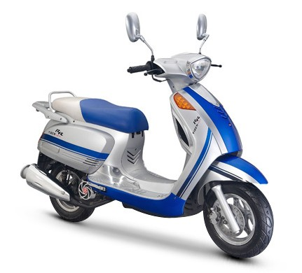 |  |  |  | 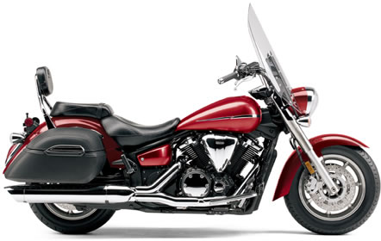
Type: |  |  |  | Type:
 |  |  |  | 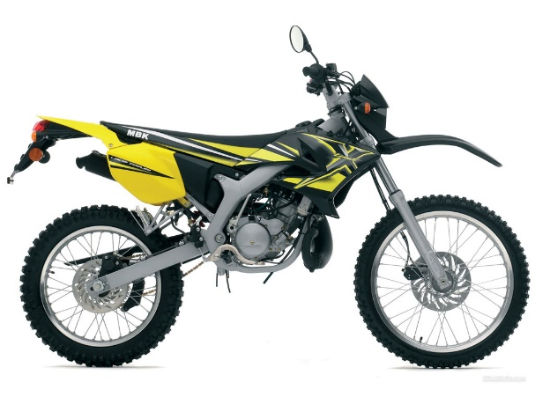
Type: |  |  | Type:

Assessor Declaration
In signing this sheet the assessor and learner confirm that all the operations in this task were carried out by the named learner and the learner observed safe working practices at all times.

Assessor Signature…………………………………………………….........Date…………………………..

Learner Signature….………………………………………………………..….Date…………………………..

Unit J/502/4674 | Assessment Criteria 2.1 | Task No 2

Task: Motorcycle Components

Instructions to Learners
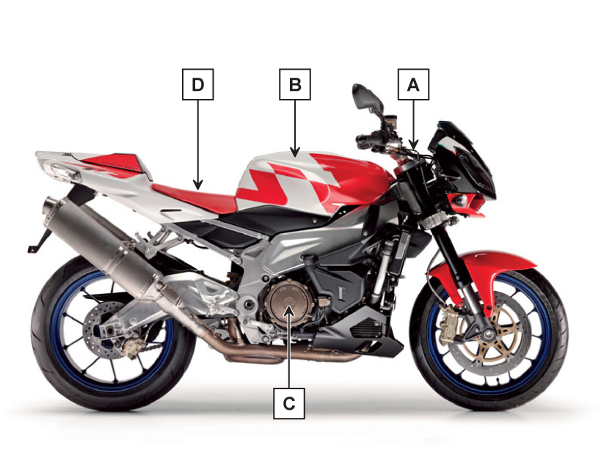
1. investigate the layout of a modern motorcycle
2. Complete the table below by identifying the lettered parts on the diagram
Component | Letter | Component | Letter
Seat |  | Fuel Tank
Engine |  | Headstock

Assessor Declaration
In signing this sheet the assessor and learner confirm that all the operations in this task were carried out by the named learner and the learner observed safe working practices at all times.

Assessor Signature…………………………………………………….........Date…………………………..

Learner Signature….………………………………………………………..….Date…………………………..

Unit J/502/4674 | Assessment Criteria 2.2 | Task No 3

Task: Motorcycle Fairings

Instructions to learner

Complete the table below by identifying the names of the fairings indicated

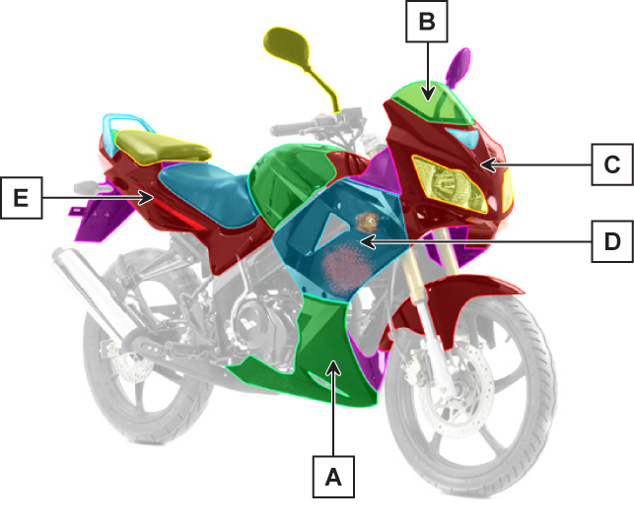

Fairing | Letter | Fairing | Letter
Windshield |  | Nose Fairing
Belly Pan |  | Seat Panel
Side Panel

Assessor Declaration
In signing this sheet the assessor and learner confirm that all the operations in this task were carried out by the named learner and the learner observed safe working practices at all times.

Assessor Signature…………………………………………………….........Date…………………………..

Learner Signature..………………………………………………………...…..Date…………………………..

Unit J/502/4674 | Assessment Criteria 3.1 | Task No 4

Task: Motorcycle Controls

Instructions to learners
From the diagrams of motorcycle and scooter controls below identify the controls indicated

Motorcycle |  |  | Scooter
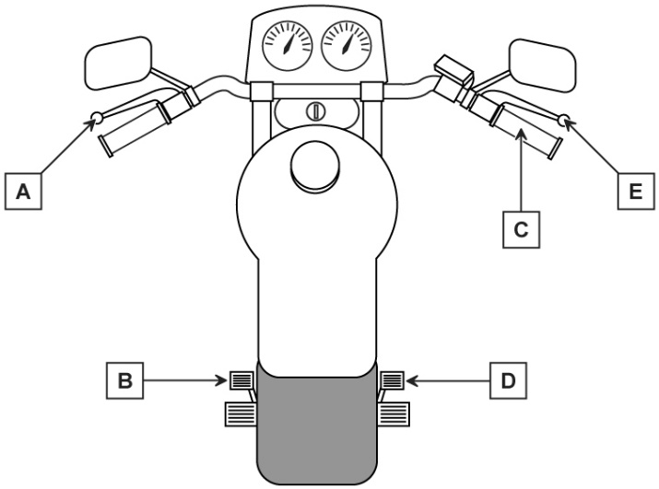 |  |  | 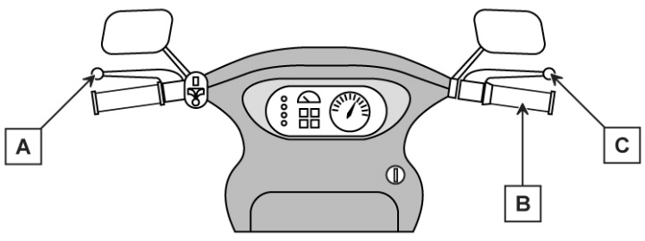
Control | Letter |  |  | Control | Letter
Clutch |  |  |  | Throttle
Throttle |  |  |  | Front Brake
Front Brake |  |  |  | Rear Brake
Rear Brake
Gear Change Lever
Why is there no gear change lever on the scooter?

Assessor Declaration
In signing this sheet the assessor and learner confirm that all the operations in this task were carried out by the named learner and the learner always observed safe working practices.

Assessor Signature…………………………………………………….........Date…………………………..

Learner Signature….………………………………………………………..….Date…………………………..

UNIT L/502/4675 ROUTINE MOTORCYCLE CHECKS

ASSESSMENT CRITERIA RECORD
Specification Reference | Assessment  Criteria | Evidence  Reference
1.1 | Identify the motorcycle systems and components that require routine checks | 1
1.2 | Identify the basic maintenance requirements for Motorcycle systems | 1
2.1 | Identify the information required for motorcycle maintenance. | 1
2.2 | Identify the tools and equipment required for motorcycle maintenance | 1
3.1 | Use safe working practices and correct methods of working | 1
3.2 | Use the appropriate personal protective equipment required for motorcycle checks | 1
3.3 | Demonstrate the correct sequence and procedure when carrying out motorcycle checks | 1

ASSESSOR FEEDBACK ON UNIT COMPLETION
This confirms unit completion and should offer supportive guidance to the learner

Unit L/502/4675 | Assessment Criteria ALL | Task No 1

Task: Periodic Maintenance

PPE Worn or Used | Special Tools
Instructions to Learners
1. Carry out a periodic maintenance check using the checklist on the next page.
2. Report any actions required.

Assessor Declaration
In signing this sheet the assessor and learner confirm that all the operations in this task were carried out by the named learner and the learner observed safe working practices at all times.

Assessor Signature…………………………………………………….........Date…………………………..

Learner Signature….………………………………………………………..….Date…………………………..

MOTORCYCLE ROUTINE MAINTENANCE
CHECKLIST

Machine Details |  |  | Data
Make_______________________________________  Model______________________________________  Year_______________________________________ |  |  | Engine oil specification
 |  |  | Transmission oil specification
 |  |  | Minimum Legal tyre tread depth
Task: | Complete | Action Items
Wheels and Tyres
Wheel Condition | F….. R…..
Tyre Condition | F….. R…...
Tyre Tread Depth | F….. R…...
Braking Systems
Front brake lever travel
Rear Brake Pedal/lever travel
Fluid level
Suspension Systems
Leakage | F ….. R…..
Security
Lighting Equipment
Front
Rear
Sop Lamp
Direction Indicators
Transmission
Fluid Level
Fluid leaks
Exhaust System
Security
Condition
Engine
Oil Level
Oil leaks

Assessor Declaration
In signing this sheet the assessor and learner confirm that all the operations in this task were carried out by the named learner and the learner observed safe working practices at all times.

Assessor Signature…………………………………………………….........Date…………………………..

Learner Signature….………………………………………………………..….Date…………………………..

UNIT M/502/4667 ROUTINE BRAKING SYSTEMS

ASSESSMENT CRITERIA RECORD

Specification Reference | Assessment  Criteria | Evidence  Reference
1.1 | Use appropriate Personal Protective Equipment and methods when working on braking systems | 2
2.1 | State the function of a vehicle braking system | 1
2.2 | State in simple terms how the driver’s effort is converted into braking forces | 1
2.3 | Identify the main components of a vehicle braking system | 1
3.1 | Remove and refit a set of disc pads | 2
3.2 | Check operation of brake lights | 2
3.3 | Check and top-up brake fluid reservoir | 2
4.1 | State how to dispose of brake friction materials | 3
4.2 | State how to dispose of brake fluid | 3

ASSESSOR FEEDBACK ON UNIT COMPLETION
This confirms unit completion and should offer supportive guidance to the learner

Unit M/502/4667 | Assessment Criteria 2.1, 2.2, 2.3 | Task No 1

Task: Function of Braking System
Recognise Braking System Components

Instructions to Learners
1. Complete the following sentences using the words in the word list

The function of the braking system is to slow a vehicle down by converting the …………. energy of the vehicle into …… energy

The drivers force on the brake pedal is converted into …………. …………… which is used to force ………. ……. or ……… onto revolving or ………..
WORD LIST
Hydraulic pressure heat brake shoes

Pads disc drums movement

2. Inspect a vehicle braking system and identify the components lettered in the diagram.
3. Complete the Braking System Components chart below

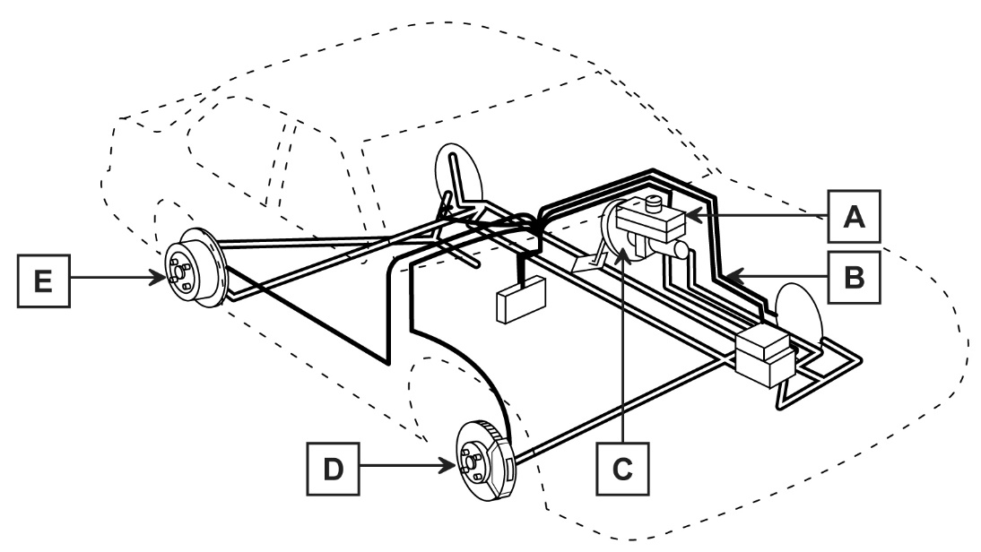
Braking System Components
Component | Letter
Disc Brake
Drum Brake
Master Cylinder
Servo

Assessor Declaration
In signing this sheet the assessor and learner confirm that all the operations in this task were carried out by the named learner and the learner observed safe working practices at all times.

Assessor Signature…………………………………………………….........Date…………………………..

Learner Signature…..………………………………………………………..….Date…………………………..

Unit M/502/4667 | Assessment Criteria 3.1 | Task No 2

Task: Remove and Replace Disc Pads

Vehicle Details | Special Tools |  | PPE Worn or used
Make_______________

Model_______________

Year________________

 |  |  | DATA
 |  |  | Wheel Nut torque
 |  |  | Brake fluid Specification
Instructions to Learners
- Position vehicle at correct working height
- Identify the wheels fitted with disc brakes
- Remove one wheel
- Remove the disc pads following manufacturers procedures
- Check pads for serviceability and report findings
- Refit pads to manufacturers specification
- Refit wheel
- Repeat on other disc brake
- Lower Vehicle and check wheel nut torque
- Press the brake pedal repeatedly to adjust pads
- Press and hold brake pedal and check for correct operation and operation of brake light
- Check hydraulic fluid level and top-up as required
- Complete report below

Component |  | Report
Brake pad condition

Brake light operation

Brake fluid level

Assessor Declaration
In signing this sheet the assessor and learner confirm that all the operations in this task were carried out by the named learner and the learner observed safe working practices at all times.

Assessor Signature…………………………………………………….........Date…………………………..

Learner Signature….………………………………………………………..….Date…………………………..

Unit M/502/4667 | Assessment Criteria 4.1, 4.2 | Task No 3

Task: Waste Disposal

Instructions to Learners
State in the spaces provided below the correct procedure for disposing of waste braking system components

Component | Correct Disposal
Brake Dust
Brake Fluid
Waste Components

Assessor Declaration
In signing this sheet the assessor and learner confirm that all the operations in this task were carried out by the named learner and the learner observed safe working practices at all times.

Assessor Signature…………………………………………………….........Date…………………………..

Learner Signature….………………………………………………………..….Date…………………………..

M/502/4670 ROUTINE VEHICLE CHECKS

ASSESSMENT CRITERIA RECORD

Specification Reference | Assessment  Criteria | Evidence  Reference
1.1 | Identify the vehicle systems and components that require routine checks. | 1
1.2 | Identify the basic maintenance requirements for vehicle systems | 1
2.1 | Identify the information required for vehicle maintenance | 1
2.2 | Identify the tools and equipment required for vehicle maintenance | 1
3.1 | Use safe working practices and correct methods of working | 1
3.2 | Use the appropriate personal protection equipment (PPE) required for vehicle checks. | 1
3.3 | Demonstrate the correct sequence and procedure when carrying out vehicle checks | 1

ASSESSOR FEEDBACK ON UNIT COMPLETION
This confirms unit completion and should offer supportive guidance to the learner

Unit M/502/4670 | Assessment Criteria All | Task No 1

Task: Carry Out Periodic Inspection

Vehicle Details | PPE Worn or Used | Tools used
Make___________________

Model__________________

Year____________________

Instructions to Learners
Following the checklist below, carry out a periodic maintenance inspection
Task |  | Action Required
Check engine oil level

Check engine coolant level

Check operation of all external lights

Check windscreen washer fluid level

Check brake fluid level

Check footbrake travel

Check handbrake lever travel

Check tyre condition

Check tyre pressure and tread depth

Check operation of all doors, bonnet and boot/hatch

Assessor Declaration
In signing this sheet the assessor and learner confirm that all the operations in this task were carried out by the named learner and the learner observed safe working practices at all times.

Assessor Signature…………………………………………………….........Date…………………………..

Learner Signature.………………………………………………………..…….Date…………………………..

F/504/1389 CLEAN A VEHICLE EXTERIOR AND INTERIOR

ASSESSMENT CRITERIA RECORD

Specification Reference | Assessment  Criteria | Evidence  Reference
1.1 | Demonstrate safe working practices when cleaning a vehicle | 1,2
1.2 | Use correct PPE required to carry out given tasks | 1,2
1.3 | Clean and store tools, equipment and PPE safely | 1,2
2.1 | Rinse off any dirt and grit from the vehicle | 1
2.2 | Wash the exterior of a vehicle | 1
2.3 | Dry the exterior of a vehicle | 1
3.1 | Remove any rubbish from the interior of the car | 2
3.2 | Remove internal floor mats | 2
3.3 | Clean internal floor mats | 2
3.4 | Clean a vehicle interior foot wells, seats, dash board and windows | 2
3.5 | Replace internal floor mats in the correct position | 2

ASSESSOR FEEDBACK ON UNIT COMPLETION
This confirms unit completion and should offer supportive guidance to the learner

Unit F/504/1389 | Assessment Criteria 1.1, 1.2, 1.3, 2.1, 2,2, 2.3 | Task No 1

Task: Clean Vehicle Exterior

Vehicle Details | Equipment Used | PPE Used or Worn
Make_______________

Model_______________

Year________________

Instructions to Learners
    - Rinse off excessive dirt and grit before washing vehicle
    - Wash the vehicle exterior and rinse
    - Dry vehicle exterior effectively
    - Examine vehicle exterior to ensure clean surface finish

Assessor Declaration
In signing this sheet the assessor and learner confirm that all the operations in this task were carried out by the named learner and the learner observed safe working practices at all times.

Assessor Signature…………………………………………………….........Date…………………………..

Learner Signature………………………………………………………..……..Date…………………………..

Unit F/504/1389 | Assessment Criteria 1.1, 1.2, 1.3, 3.1, 3.2, 3.3, 3.4, 3.5 | Task No 2

Task: Valet Vehicle Interior

Vehicle Details | Equipment used | PPE worn or Used
Make_______________

Model_______________

Year________________

Instructions to Learners
- Remove any rubbish from the interior of the car
- Remove internal floor mats
- Clean internal floor mats
- Vacuum vehicle interior
- Clean interior glass ensuring no smears are left
- Restore the appearance of interior plastic trim
- refit internal floor mats
- Check vehicle interior to ensure surface finish

Assessor Declaration
In signing this sheet the assessor and learner confirm that all the operations in this task were carried out by the named learner and the learner observed safe working practices at all times.

Assessor Signature…………………………………………………….........Date…………………………..

Learner Signature.………………………………………………………..…...Date……………………………

T/504/1390 REMOVE AND REPLACE SPARK PLUGS

ASSESSMENT CRITERIA RECORD

Specification Reference | Assessment  Criteria | Evidence  Reference
1.1 | Demonstrate safe working practices when removing and replacing spark plugs | 1
1.2 | Use correct PPE required to carry out given tasks | 1
1.3 | Dispose of waste products in line with environmental guidance | 1
1.4 | Clean and store tools, equipment and PPE safely | 1
2.1 | Locate the spark plugs | 1
2.2 | Remove and replace the spark plugs in the correct sequence | 1
2.3 | Ensure all spark plugs are replaced securely | 1

ASSESSOR FEEDBACK ON UNIT COMPLETION
This confirms unit completion and should offer supportive guidance to the learner

Unit T/504/1390 | Assessment Criteria All | Task No 1

Task: Remove, Check and Replace Spark Plug

Vehicle Details | Special Tools | Data
Make_______________  Model_______________  Year________________ |  | Position of No1 Spark plug
 |  | Spark Plug Make
 | PPE Worn or Used
 |  | Spark Plug Specification
 |  | Spark Plug Condition
Instructions to Learners
1. Identify number 1 spark plug
2. Remove No.1 spark plug
3. Re-gap as required
4. Refit spark plug
5 Remove and refit all other spark plugs
6. Assessor to Start engine and check for correct operation and throttle response

Note
Ignition HT systems run at very high voltage and care must be taken when working on running engines to avoid electric shocks

Assessor Declaration
In signing this sheet the assessor and learner confirm that all the operations in this task were carried out by the named learner and the learner observed safe working practices at all times.

Assessor Signature…………………………………………………….........Date…………………………..

Learner Signature..………………………………………………………..……Date…………………………..

M/501/7024 INTRODUCTION TO VEHICLE EXHAUST SYSTEMS

ASSESSMENT CRITERIA RECORD

Specification Reference | Assessment  Criteria | Evidence  Reference
1. Work safely | 1.1 Use safe working practices when working with vehicle exhaust systems | 1,2,3,4
2. Know the main components of a vehicle exhaust system | 2.1 Identify and locate the main components of a vehicle exhaust system to include:  - Manifold  - Catalytic converter  - Oxygen sensor  - Front pipe  - Silencer | 1
3. Know how to inspect a vehicle exhaust system | 3.1 Give examples of common exhaust faults  3.2 Perform visual inspection of exhaust system for serviceability with particular attention to leakage, corrosion, damage and security  3.3 Identify key findings of inspection | 2
4. Know how to replace a vehicle exhaust component | 4.1 Remove an exhaust component  4.2 Identify the correct replacement component for a specified vehicle  4.3 Fit an exhaust component in accordance with manufacturers guidance  4.4 Perform inspection to ensure correct alignment, security and sealing | 3
5. Be aware of environmental considerations | 5.1 Demonstrate appropriate ways to dispose of waste products in accordance with environmental guidance | 4

ASSESSOR FEEDBACK ON UNIT COMPLETION
This confirms unit completion and should offer supportive guidance to the learner

Unit M/501/7024 | Assessment Criteria 2.1 | Task No 1

Task: Identify Exhaust Components

Instructions to Learners
1. Examine an exhaust system on a vehicle and compare to the diagram below.
2. Identify the components numbered on the diagram and complete the table.
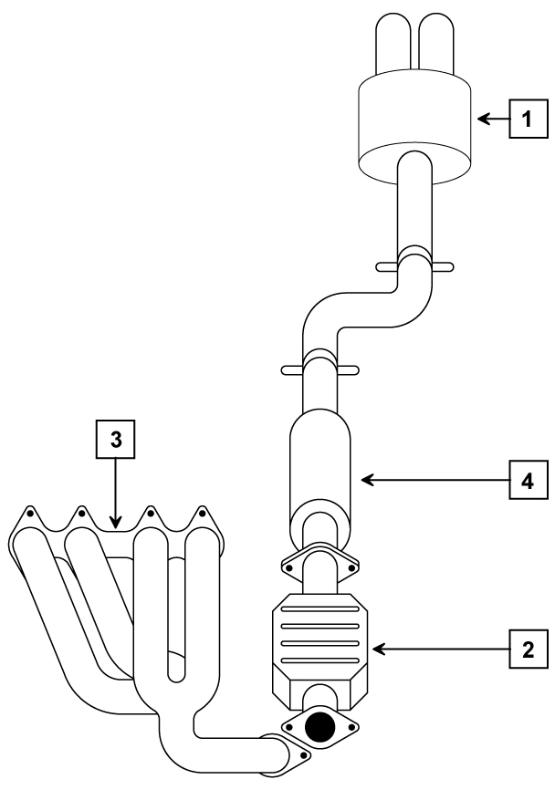
Number | Component
 | Manifold
 | Front Pipe
 | Middle Silencer
 | Rear Silencer

Assessor Declaration
In signing this sheet the assessor and learner confirm that all the operations in this task were carried out by the named learner and the learner observed safe working practices at all times.

Assessor Signature……………………………………………………........Date…………………………..

Learner Signature….………………………………………………………..…Date…………………………..

Unit M/501/7024 | Assessment Criteria3.1, 3.2, 3.3 | Task No 2

Task: Exhaust System Inspection

Instructions to Learners
1. Examine a vehicle exhaust system for faults
2. Complete the inspection report noting findings.
Exhaust Condition Report
Component | Leakage | Corrosion | Damage | Security
Manifold
Exhaust Pipes
Silencers
Support Brackets
Catalytic Converter

Assessor Declaration
In signing this sheet the assessor and learner confirm that all the operations in this task were carried out by the named learner and the learner observed safe working practices at all times.

Assessor Signature……………………………………………………........Date…………………………..

Learner Signature..………………………………………………………..….Date…………………………..

Unit M/501/7024 | Assessment Criteria 4.1, 4.2, 4.3 & 4.4 | Task No 3

Task: Replace Exhaust Section

Vehicle Details | Special Tools | Exhaust Section Replaced
Make_______________

Model_______________

Year________________

Instructions to Learners
- Position vehicle at correct working height
- Remove exhaust section and mountings
- Identify correct replacement section
- Replace exhaust section
- Run engine and check for exhaust system leakage and correct positioning

Assessor Declaration
In signing this sheet the assessor and learner confirm that all the operations in this task were carried out by the named learner and the learner observed safe working practices at all times.

Assessor Signature…………………………………………………….........Date…………………………..

Learner Signature….………………………………………………………..….Date…………………………..

Unit M/501/7024 | Assessment Criteria 5.1 | Task No 4

Task: Waste Disposal

Instructions to Learners
State in the spaces provided below the correct procedure for disposing of waste exhaust components

Component | Correct Disposal
Exhaust Pipes
Catalytic Converter
Rubber Mountings
Exhaust Silencers

Assessor Declaration
In signing this sheet the assessor and learner confirm that all the operations in this task were carried out by the named learner and the learner observed safe working practices at all times.

Assessor Signature…………………………………………………….........Date…………………………..

Learner Signature…..………………………………………………………..…Date…………………………..

A/501/7026 INTRODUCTION TO VEHICLE IGNITION SYSTEMS

ASSESSMENT CRITERIA RECORD

Specification Reference | Assessment  Criteria | Evidence  Reference*
1. Work safely | 1.1 Use safe working practices when working with vehicle ignition systems  1.2 Identify and avoid specific risks associated with high tension systems | 1,2,3,4
2. Know the main components of a vehicle ignition system | 2.1 Identify and locate the main components of a vehicle ignition system to include:  - Ignition coils  - Spark plug leads  - Spark plugs  2.2 Identify the primary purpose of each | 1
3. Know how to replace a vehicle ignition component | 3.1 Remove and replace an ignition coil  3.2 Remove, inspect and measure the resistance of an HT lead using correct equipment  3.3 Replace the HT lead in the correct position  3.4 Remove and examine spark plugs to identify signs of wear  3.5 Replace spark plugs in accordance with manufacturers’ guidance  3.6 Start engine to check correct engine operation and throttle response | 2,3
4. Be aware of environmental considerations | 4.1 Demonstrate appropriate ways to dispose of waste products in accordance with environmental guidance | 4
*Where evidence is provided through responses to underpinning knowledge tests, a copy of the responses must be included as part of the evidence. An evidence reference should be added to the column.
ASSESSOR FEEDBACK ON UNIT COMPLETION
This confirms unit completion and should offer supportive guidance to the learner

Unit A/501/7026 | Assessment Criteria 2.1, 2.2 | Task No 1

Task: Ignition System Inspection

Instructions to Learners
1. Inspect the ignition system of a modern engine.
2. Identify the arrowed components in the diagram below.
3. Name each component and state the purpose of each
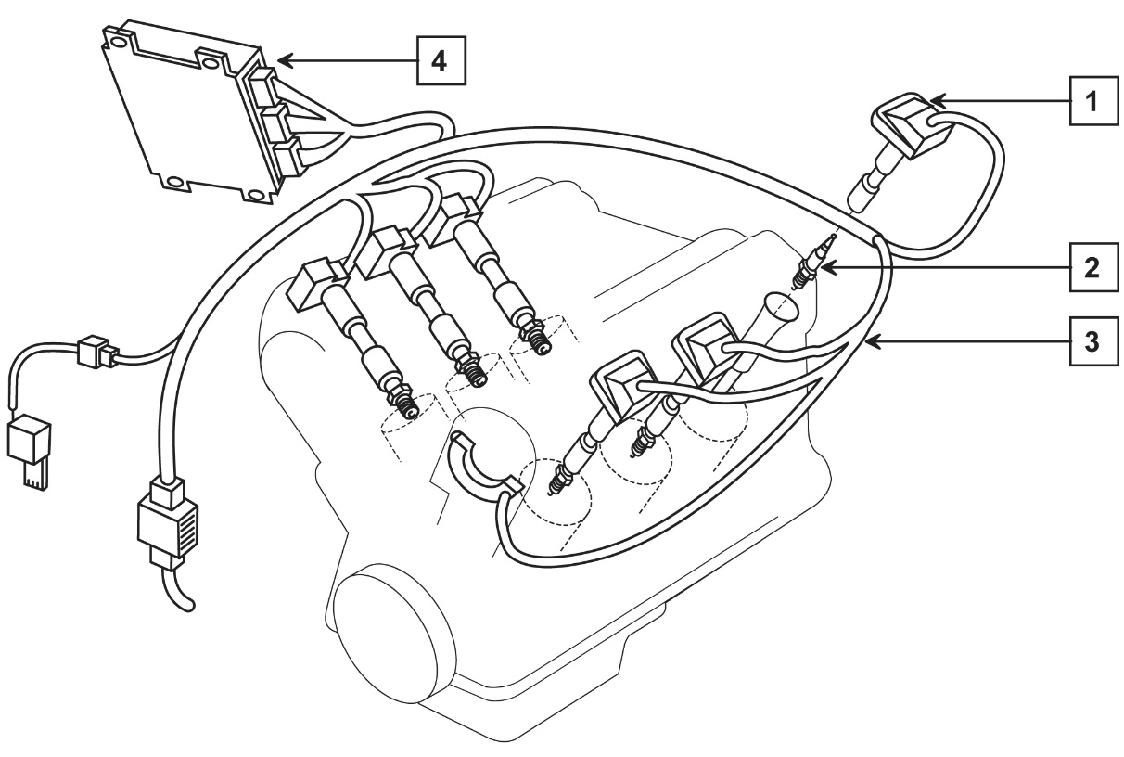
Number | Component | Purpose
1
2
3
4

Assessor Checklist | Achieved  Y/N
PPE selected and used correctly
Methodical Procedures used
Report completed

Assessor Declaration
In signing this sheet the assessor and learner confirm that all the operations in this task were carried out by the named learner and the learner observed safe working practices at all times.

Assessor Signature……………………………………………………..........Date…………………………..

Learner Signature.………………………………………………………..……..Date…………………………..

Unit A/501/7026 | Assessment Criteria 3.1, 3.2, 3.3 & 3.6 | Task No 2

Task: Remove and Refit Ignition Coil
Remove and Refit Ignition HT Lead

Vehicle Details | Special Tools | Data
Make_______________  Model_______________  Year________________ |  | Ignition Coil Primary Resistance
 |  | Actual
 |  | Recommended
 |  | HT Lead Resistance
 |  | Actual
 |  | Recommended
Instructions to Learners
1. Locate Ignition Coil
2. Remove Ignition Coil
3. Measure primary winding resistance and report
4. Refit Ignition Coil.
5. Remove HT lead from No.1 spark plug
6. Measure lead resistance and report
7. Refit lead
8. Start engine and check for correct operation and throttle response

NOTE
Ignition HT systems run at very high voltage and care must be taken when working on running engines to avoid electric shocks

Assessor Checklist | Achieved  Y/N
PPE selected and used correctly
Methodical Procedures used
Data completed

Assessor Declaration
In signing this sheet the assessor and learner confirm that all the operations in this task were carried out by the named learner and the learner observed safe working practices at all times.

Assessor Signature…………………………………………………….........Date…………………………..

Learner Signature.………………………………………………………..…….Date……………………………

Unit 17 (A/501/7026) | Assessment Criteria 3.4, 3.5 & 3.6 | Task No 3

Task: Remove, Check and Replace Sparking Plug

Vehicle Details | Special Tools | Data
Make_______________  Model_______________  Year________________ |  | Position of No1 sparking plug
 |  | Sparking Plug Make
 |  | Sparking Plug Specification
 |  | Spark Plug Condition
Instructions to Learners
1. Identify number 1 sparking plug
2. Remove No.1 spark plug
3. Check spark plug for condition and report
4. Re-gap as required
5. Refit sparking plug
6. Start engine and check for correct operation and throttle response

Note
Ignition HT systems run at very high voltage and care must be taken when working on running engines to avoid electric shocks

Assessor Checklist | Achieved  Y/N
PPE selected and used correctly
Methodical Procedures used
Data completed

Assessor Declaration
In signing this sheet the assessor and learner confirm that all the operations in this task were carried out by the named learner and the learner observed safe working practices at all times.

Assessor Signature……………………………………………………..........Date………………………….

Learner Signature..………………………………………………………...……Date………………………….

Unit 17 (A/501/7026) | Assessment Criteria 4.1 | Task No 4

Task: Waste Disposal

Instructions to Learners
State in the spaces provided below the correct procedure for disposing of waste ignition components IN YOUR WORKSHOP

Component | Correct Disposal
Sparking Plugs
Used components

Assessor Checklist | Achieved  Y/N
PPE selected and used correctly
Methodical Procedures used
Report completed

Assessor Declaration
In signing this sheet the assessor and learner confirm that all the operations in this task were carried out by the named learner and the learner observed safe working practices at all times.

Assessor Signature……………………………………………………..........Date…………………………...

Learner Signature.………………………………………………………..……..Date…………………………….

Unit D/501/7021 INTRODUCTION TO CUSTOMER CARE

ASSESSMENT CRITERIA RECORD

Specification Reference | Assessment  Criteria | Evidence  Reference
1. Recognise the elements of positive customer experience | 1.1 Give an example of a positive customer experience  1.2 Give an example of a negative customer experience | 1
2. Understand the importance of the customer’s experience to a business | 2.1 Indicate how positive and negative customer experience could affect a business | 1
3. Recognise own contribution to customer experience | 3.1 Identify and demonstrate behaviors that would contribute to a positive customer experience when:  - greeting a customer  - answering customer questions  - relaying customer information or requests to the correct workplace person  3.2 Identify and demonstrate behaviors that would contribute to a negative customer experience when:  - greeting a customer  - answering customer questions  - relaying customer information or requests to the correct workplace person | 1  2  1  2
4. Know how to promote customer safety | 4.1 Identify and demonstrate customer safety procedures | 3

ASSESSOR FEEDBACK ON UNIT COMPLETION
This confirms unit completion and should offer supportive guidance to the learner

Unit D/501/7021 | Assessment Criteria 1.1, 1.2, 2.1, 3.1(Part) 3.2(Part) | Task No 1

Task: Examples of Customer Experience

Instructions to Learners
Below are three case studies of dealing with customers.
1. In each case state how you would deal with the situation ensuring a POSITIVE customer experience
2. In each case state the behavior that would result in a NEGATIVE customer experience and how this might affect the business

Case Study 1
It is 4.00 o’clock in the afternoon and you have been asked to inquire what a male customer in reception requires. How would you introduce yourself?

Positive Customer Experience

……………………………………………………………………………………………………………………

……………………………………………………………………………………………………………………

Negative Customer Experience

……………………………………………………………………………………………………………………

……………………………………………………………………………………………………………………

Effect on Business

……………………………………………………………………………………………………………………

……………………………………………………………………………………………………………………

Case Study 2
The manager of the company has asked you to ask a female customer standing in the workshop if she will wait in the customer reception area. How would you do this?
Positive Customer Experience

……………………………………………………………………………………………………………………

…………………………………………………………………………………………………………………..
Negative Customer Experience

……………………………………………………………………………………………………………………

……………………………………………………………………………………………………………………
Effect on Business

……………………………………………………………………………………………………………………

……………………………………………………………………………………………………………………

Case Study 3
A male customer has been waiting in the reception area for about an hour, he asks you how much longer it will take to repair his vehicle. How would you answer him and what would you do?
Positive Customer Experience

……………………………………………………………………………………………………………………

…………………………………………………………………………………………………………………..

Negative Customer Experience

……………………………………………………………………………………………………………………

……………………………………………………………………………………………………………………

Effect on Business

……………………………………………………………………………………………………………………

……………………………………………………………………………………………………………………

Assessor Declaration
In signing this sheet the assessor and learner confirm that all the operations in this task were carried out by the named learner and the learner observed safe working practices at all times.

Assessor Signature…………………………………………………….........Date…………………………..

Learner Signature….………………………………………………………..….Date…………………………..

Unit D/501/7021 | Assessment Criteria 3.1 & 3.2 | Task No 2

Task: Dealing with Customers

Instructions to Learners
You are required to demonstrate good customer care by dealing direct with customers in a variety of situations. You will be observed by your assessor in each case
Instructions to the Assessor
You are to observe the learner dealing with customers and are required to complete and sign the observation sheets below.

1. Learner Greets Customer
Situation

………………………………………………………………………………………………………………………………

Assessor Report

………………………………………………………………………………………………………………………………

………………………………………………………………………………………………………………………………

Assessor Signature…………………………………………………….............. Date……………………………

2. Learner Answers Customer Question
Situation

………………………………………………………………………………………………………………………………

Assessor Report

………………………………………………………………………………………………………………………………

………………………………………………………………………………………………………………………………

Assessor Signature…………………………………………………….............. Date…………………………….

3. Learner Relays Customer Information or requests to Correct Workplace Person
Situation

………………………………………………………………………………………………………………………………

Assessor Report

………………………………………………………………………………………………………………………………

……………………………………………………………………………………………………………………..........

Assessor Signature…………………………………………………….............. Date……………………………

Unit D/501/7021 | Assessment Criteria 4.1 | Task No 3

Task: Examples of Customer Experience

Instructions to Learners
Any Motor Vehicle repair establishment can present hazards to safety by the nature of the work involved.

Customers may not be aware of these hazards and so it is important to identify customer safety procedures

Complete the table below listing THREE safety hazards and THREE methods of ensuring customer safety whilst visiting a motor vehicle repair establishment.

Hazard | Method
1. | 1.
2. | 2.
3. | 3.

Assessor Declaration
In signing this sheet the assessor and learner confirm that all the operations in this task were carried out by the named learner and the learner observed safe working practices at all times.

Assessor Signature…………………………………………………….........Date…………………………..

Learner Signature…..………………………………………………………..….Date………………………….

Unless otherwise stated e.g. for some entry level qualifications, learners can work together but should identify sections which are their own work.

